UT5 STD

**Table of contents**

Unified Solution Portal 3

Rule Management 3

Bulk Payments 6

Bulk Payments Maker 7

Bulk Payment Checker 13

**Unified Solution Portal**

**Rule Management**

Introduction

The **Rules** menu allows you to set conditions for a particular operation. According to this, specific fees and commissions, for both financial and non-financial operations apply.

The menu also allows defining a limiting conditions that forbid usage over an operation, i.e. a so called limit.

Fees, commissions and limitsare determined by the composition of conditions for a rule, which are the actual properties of a channel, operation, operation source and destination, operation cumulative, periods and amount conditions.

|  |  |
| --- | --- |
| **Components** | **Description** |
| **Rules** | Logic for charges or blocking of services in specific condition is managed by creation of **rules**. Each **rule** describes the operation and its participants` (actors) specifics by using conditions. The conditions indicate “when” the rule in question applies and what action should be eventually taken during the operation |
| **Priorities** | A **Priority** is the main rule value, according to which a particular rule is considered applicable when more than one is valid. |
| **Channel** | By means of the channel (such as Agent, ATM, POS, Teller, USSD/SMS, etc), the operation is conducted from one actor to another. |
| **Operation** | It is a service or transaction performed. |
| **Limits** | **Limits** are used as limitation to forbid specific operation execution by specifying the maximum operation amount allowed per currency, maximum summarized amount volume or count of operations allowed per relative period (monthly, weekly, daily). |
| **Fees** | **Fees** are the money taken as charge for a particular action (service), specified by the conditions. The fee is collected by the financial institution as a charge for the service. Then, it can be shared with other parties (agents, operators, service providers, etc).  Fees are defined as a percentage or flat value. |
| **Commissions** | **Commissions** are the money given as a profit from the action specified by the conditions. |
| **Split** | **Split** represents the division of the commissions and fees for particular operation transmission. |

Creating a Rule

To create a new rule for your organization:

1. Go to **Rules** and click the **Create Rule** button.
2. In the new **Add Rule** window, enter the following information:

* In the **Priority** field set the priority order (number) of the rule . Priority is mandatory and is used to find which rule applies when more than one is valid.
* In the **Channel** panel set up one or more conditions of the channel properties, such as **Type** and **Role**.  
    
  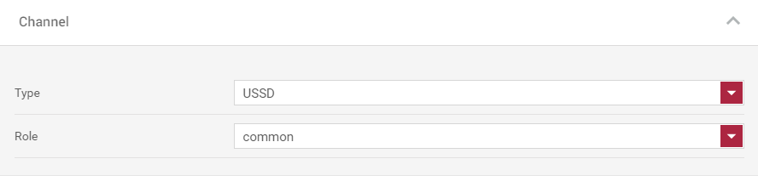
* In the **Operation** panel specify the type of the operation.  
    
    
  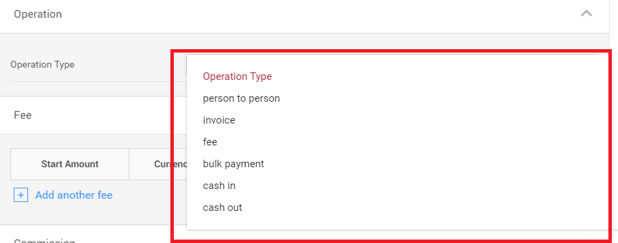
* In the **Fee** and **Commissions** panels define the split range of the commissions and fees, by clicking the **Add another fee/ commission** button.
* In the **Start Amount** field enter enter the start amount range of the operation. The range ends at the next Range Amount start. The current operation amount is checked within which range it falls in, and the corresponding calculation is returned
* From the **Currency** drop-down select the currency of the operation.
* In the percentage field enter the percentage of the fee/commission, which is calculated based on the total operation amount.
* In the **%Base** field enter the base number for percentage calculation. If the %Base number is higher than the transaction amount, the percentage calculation value is 0.
* In the **Min Amount** field enter the flat number for minimum value of the calculated percentage. If the calculated percentage value from the operation amount is lower than Min value, the Min value will be returned. If there is no percentage value set, but there is a Min value, then Min value will be returned. This way a flat charge can be set.
* In the **Max Amount** field enter the flat number for maximum value of the calculated percentage. If the calculated percentage value from the operation amount is higher than Max value, the Max value will be returned.  
    
    
  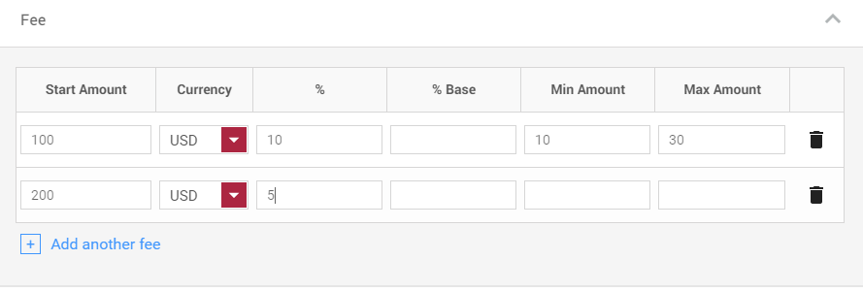

* In the **Limit** panel specify the currency and limitation of the maximum allowed value of operations for a relative period of time: daily, weekly or monthly, by clicking the **Add Another Limit** button.
* In the **Transactions** field enter the **Minimum** and **Maximum** amount of the operation per transaction.
* In the **Daily** field enter the **Maximum** amount and **Count** of the operation/s per day.
* In the **Weekly** field enter the **Maximum** amount and **Count** of the operation/s per week.
* In the **Monthly** field enter the **Maximum** and **Count** amount of the operation/s per month.

**NOTE:**  You can delete the entire limit record using the delete  button.

1. Review the information in the **Summary** panel and click the **Save** button.

**NOTE:** A rule cannot be created if there is already an existing rule with the exact same priority.

Editing a Rule

To edit a rule:

1. Go to **Rules** and select the rule that you want to edit.
2. Click the **Edit** button. The new **Edit Rule** window appears.
3. Change the necessary information and click the **Save** button (or click **Close** to discard).

Deleting a Rule

To delete a Rule:

1. Go to **Rules** and select the rule that you want to delete.
2. Click the **Delete** button. The following message: *" You are about to delete 1 rule. Would you like to proceed?"* appears.
3. Click **OK** to permanently delete the selected rule.

The rule is no longer visible in the grid.

**Bulk Payments**

Introduction

Entitled persons can debit or credit multiple accounts using a text or Excel file formatted according to a predefined template for bulk operations like settlements, transaction reversals, partner payments, etc.  
  
  
 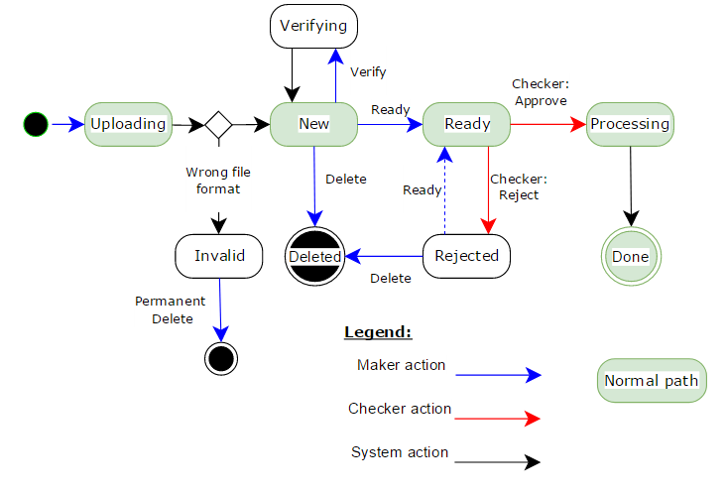

**Bulk Payments Maker**

Creating Bulk Batches

You can create a new bulk batch by uploading a .csv document, only if you have aBulk Payments Maker role.

To create a new bulk batch:

1. Go to **Bulk Payments** and click the **Upload Batch** button.
2. In the new **Upload Batch Payment** screen:

* In the **Batch Name** field enter a name for the new batch.
* In the **Upload** **Batch** field, click the **Browse** button to upload a valid .csv file that contains all the necessary information.
* Select the **Check batch after upload** check box to perform an automatic verification of the information. Clear the check box if you want to do the verification at a later stage.  
    
    
  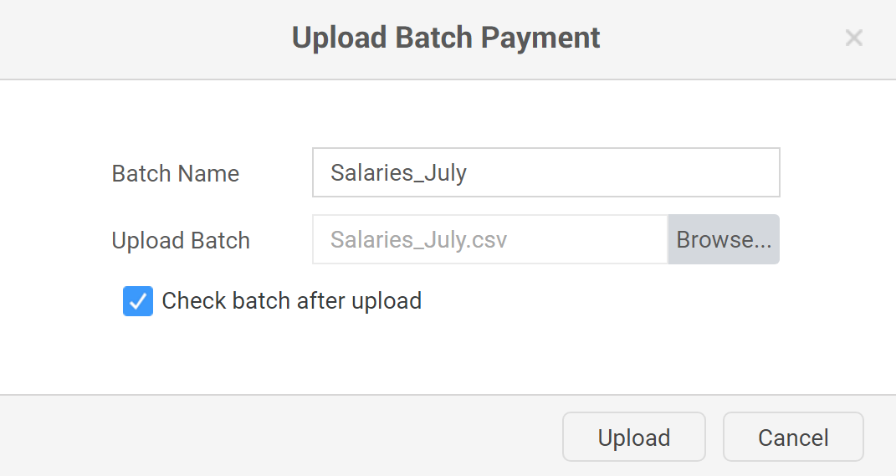

1. Click the **Upload** button to create a batch. The following message: " *Successfully uploaded N entities"* appears.
2. Click **Close** to close the window.

The newly created batch is in status **New** and is available in the bulk batches list.

**NOTE**: If you upload a broken file, the status of the new batch changes to **Invalid**.

Visualizing Batch Records

To view bulk payment records:

1. Go to **Bulk Payments** and select the batch that you want to review.
2. Click the **View Batch Records** button. A new screen, showing all batch payment records appears.
3. You can filter the displayed information by:

* **Name**, **National ID** or **Sequence Number** of the record.
* **Status** - from the **Status** drop-down select the status of the batch record.
* **Date** - from the datepicker menu select a date of birth of a particular user.

Editing Batch Records

You can edit batch payment records only if you have a Bulk Payments Maker role.

To edit batch payment records:

1. Go to **Bulk Payments** and select the batch, which records you want to edit.
2. Click the **View Batch Records** button. A new screen, showing all batch payment records appears.
3. Select a payment record and click the **Details** button. The **Payment Details** window displays.

**NOTE**: The **Comment** field displays detailed information about the result of the record verification

1. Change the necessary information and click the **Save** button.

According to the validity of the submitted information the status of the record changes to **Verified** or **Mismatch**.

Checking Batch Records

To check batch record details:

1. Select the batch, which details you want to check and click the **View Batch Records** button. A new screen, showing all batch payment records appears.
2. Select a payment record from the list and click the **Check Records** button. The system performs an automatic verification of the submitted information.

If the payment transaction details correspond to the information in the system, the status of the record changes to **Verified**.

If the payment transaction details do not correspond to the information in the system, the status of the record changes to **Mismatch**.

Disabling Batch Records

To disable a batch record:

1. Go to **Bulk Payments** and select a batch.
2. Click the **View Batch Records** button. A new screen, showing all batch payment records appears.
3. Select a payment record and click the **Disable** button.

The status of the record changes to **Disabled**.

When a record is in status **Disabled**, this means that upon the batch processing, this particular transaction would not be executed.

Editing Batch Details

You can edit bulk batch details only if you have a Bulk Payments Maker role.

To edit bulk batch details:

1. Go to **Bulk Payments** and select a specific batch.
2. Click the **Details** button. The **Batch Details** window, showing all batch details appears.   
     
     
   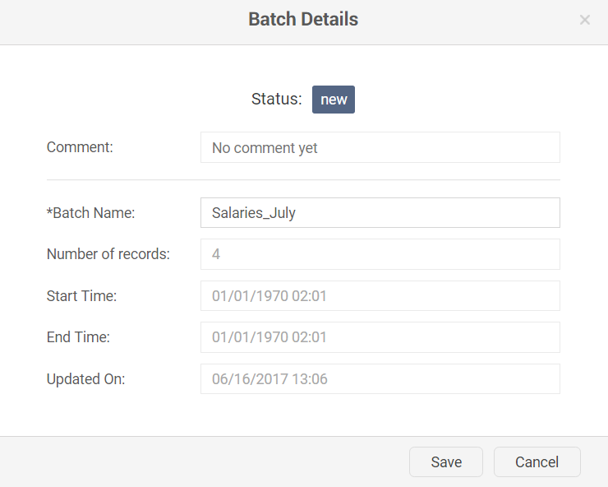
3. In the **Batch Name** field change the name of the batch.

**NOTE:** You cannot edit the following fields: **Comment**, **Number** **of records**, **Updated** **On**.

1. Click the **Save** button to save the changes.

Sending Ready Batch for Execution

Once you check all batch record details, you can send the batch for execution only if you have Bulk Payments Maker role.

To send a ready batch for execution:

1. Go to **Bulk Payments** and filter all batches in status **New**.
2. Select the batch that you want to mark as ready for execution and click the **View Batch Records** button. A newwindow with all batch record details appears.
3. Click the **Batch Ready** button to send the batch to the checker for further check and execution.

The status of the batch changes to **Ready** until the checker approves the execution of the transactions.

Once the checker approves the transactions, the status of the batch changes from **Ready** to **Processing** > **Done**.

Deleting Bulk Batches

To delete a bulk batch:

1. Go to **Bulk Payments** and filter all batches in status **New**.
2. Select the batch that you want to delete and click the **Delete** button. A new **Delete Batch** window appears:
3. In the **Enter Reason** field enter the reason for the delete of the batch.
4. Click the **Delete** button to confirm the action.

The bulk batch is no longer visible in the grid.

Filtering Bulk Batches

To filter bulk batches:

1. You can filter all batches by:

* **Name** - in the **Search** field enter the exact name of the batch.
* **Status** - from the **Select Status** drop-down menu select the status of the batch.
* **Date** - click the  button to select the activation's period in the From/To fields to filter by **Date of Activation**.   
    
  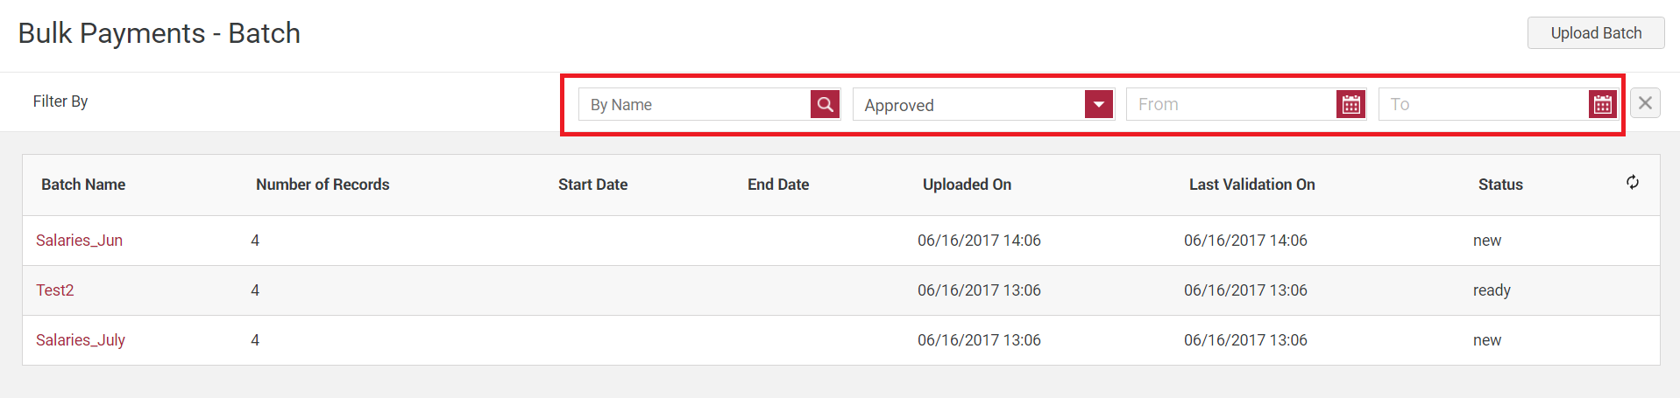

**Bulk Payment Checker**

Filtering and Visualizing Bulk Batch Records

To view all details of the bulk payment records:

1. Go to **Bulk Payments** and select the batch that you want to review records for.
2. Click the **View Batch Records** button. A new screen, showing the respective information appears.
3. Select the batch record, which details you want to review and click the **Details** button. The **Payment Details** window displays.
4. Review the information and click the **Cancel** button to close the window.

**NOTE:** As a bulk payment checker you cannot change any of the displayed information.

To filter bulk batch records:

1. You can filter the displayed information by:

* **Name**, **National ID** or **Sequence Number** of the record.
* **Status** - from the **Status** drop-down select the status of the batch record.
* **Date** - from the datepicker menu select the user`s date of birth.

Visualizing Bulk Batch Details

To view bulk batch details:

1. Go to **Bulk Payments** and select a specific batch.
2. Click the **Details** button. The **Batch Details** window, showing all details information appears.   
     
   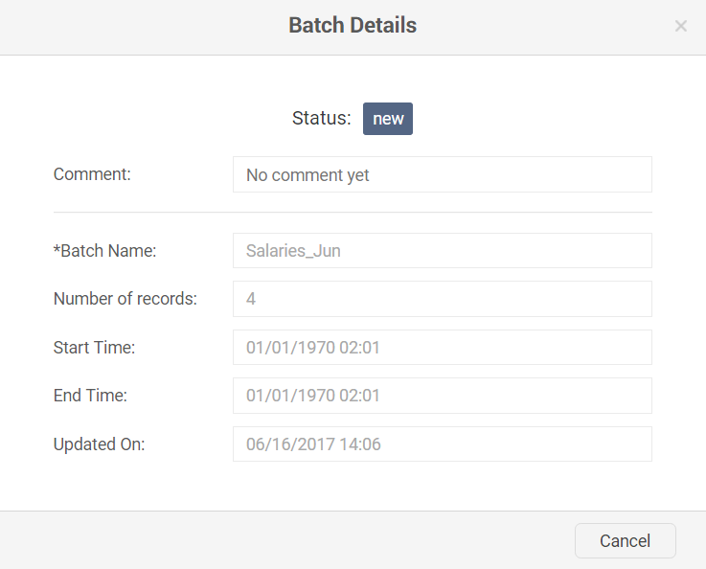
3. Click **Cancel** to close the window.

Checking Bulk Batch Records

To check batch records execution details:

1. Go to **Bulk Payments** and filter all batches in status **Ready.**
2. Select the batch that you want to check all record details for and click the **View Batch Records** button. A new screen, showing all batch records displays.
3. Select the batch record which details you want to check and click the **Check Records** button. The system performs an automatic verification of the submitted information.

If the payment transaction details correspond to the information in the system, the status of the record changes to **Verified**.

If the payment transaction details do not correspond to the information in the system, the status of the record changes to **Mismatch**.

Executing Bulk Batch Payments

To execute a bulk payment:

1. Go to **Bulk Payments** and filter all batches in status **Ready**.
2. Select the batch that you want to execute payments for and click the **View Batch Records** button. A new screen with all batch records displays.
3. Click the **Pay Batch** button to proceed with the payment execution. A new **Pay Batch** window appears.

NOTE: The **Pay Batch** and **Reject Batch** buttons are active only if the batch is in status **Ready**.

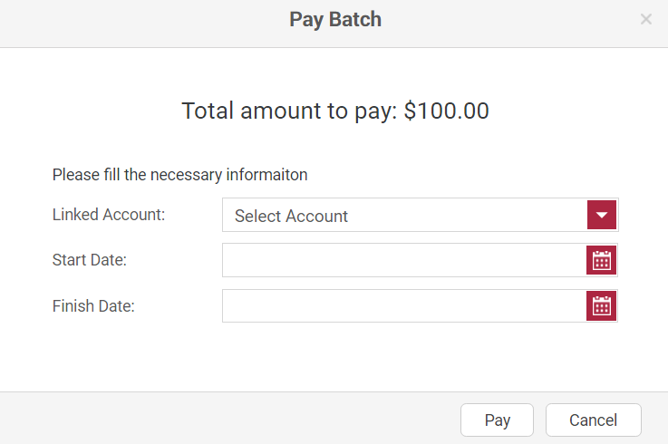

1. From the **Linked Account** drop-down menu select the source account, which the money should be sent from.
2. From the **Start and** **Finish Date** menu select the retries start and end dates.
3. Click **Pay** to execute the payment.

The status of the batch changes to **Processing** until the payments are successfully executed. Once the payments are completed, the status of the batch changes to **Done**.

Rejecting Bulk Batch Payments

You can reject and return bulk batch payments to the Bulk Payments Maker for edit only if you have a Bulk Payments Checker role.

To reject bulk batch payments:

1. Go to **Bulk Payments** and filter all batches in status **Ready**.
2. Select a particular batch and click the **View Batch Records** button. A new screen, showing all batch record details appears.
3. Review all the available information and click the **Reject Batch** button to reject the batch payments.

The status of the batch changes to **Rejected** until it is edited by theBulk Batch Maker.